ABYSS Project
Multi-disciplinary Project – 2006 IS1 v1.0
Abyss User manual.
Group n 307
5/5/2007



Table of Contents

Introduction 3
About Abyss Client 3
Launching/Authentication 4
Main Window 5
Active Directory 6
Manage Users 6
Manage Computers 8
Manage Groups 10
Oracle 10g 13

Introduction

Welcome to the official documentation of Abyss Client. Abyss System thanks you for using this product and hope that your experience will be rewarding and constructive. This documentation explains in detail the functionality of Abyss Client for a better utilization from users.

About Abyss Client

Abyss Client is the all in one administrative application for industrial production server based on Windows 2003 Server R2 and Oracle Database 10g R1/R2.

If you have just acquired Abyss Client and want to use it, follow the guide step by step to obtain an operational server with Active Directory and Oracle Database in function.

Abyss Client can be executed directly from your server, a computer of your domain or from a distant client (on the same local network of your server) who has administrative rights.

Launching/Authentication

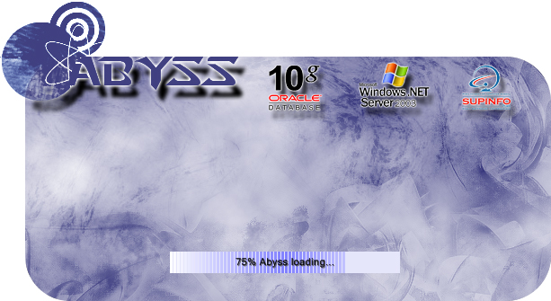
When you launch Abyss, please wait during the loading.

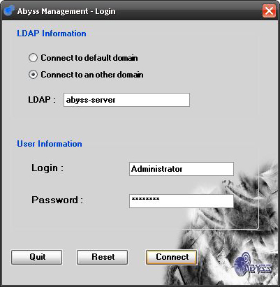
Then, you can log you to your domain with your Login and your Password.

Main Window

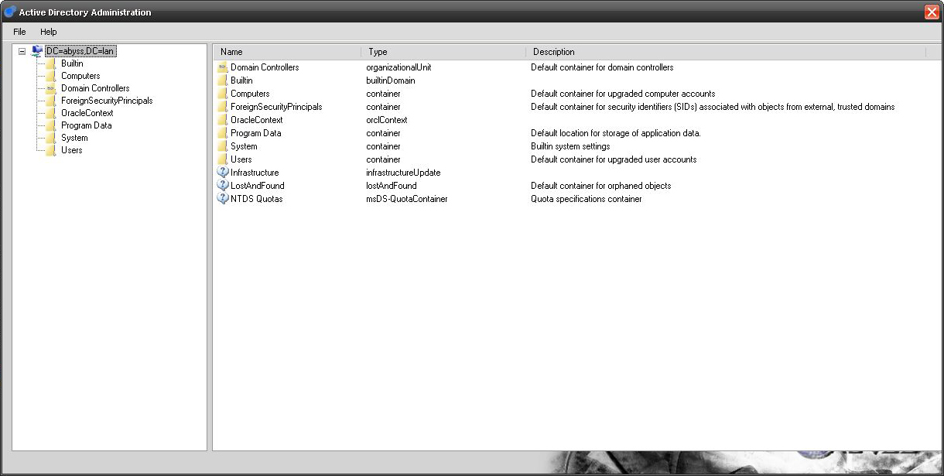
The first window shows your Domain Architecture directly from Active Directory. You can see your Users, your Computers, your Groups and create/modify them.
You can see too a lot of information about your Domain and connect to the Oracle Administration’s part.

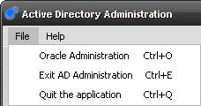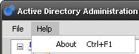
By clicking on File in the top right corner, you can turn to “Oracle Administration”, “Exit Active Directory or “Quit the Application”. You can too use some shortcuts likes “Ctrl+O” for Oracle Administration, “Ctrl+E” for “Exit AD Administration” and “Ctrl+Q” to “Quit the application”.
In the Help tab, you can show some information about developers (or press “Ctrl+F1”).

Active Directory

Manage Users

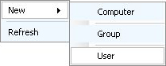
To Create a User, make a right click somewhere on the tree view and click on User.

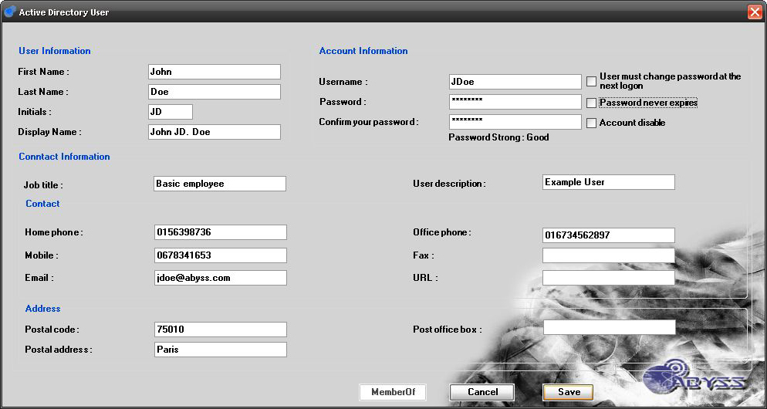
The User’s window open and allow you to create one.

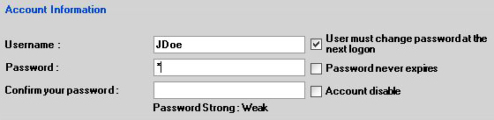

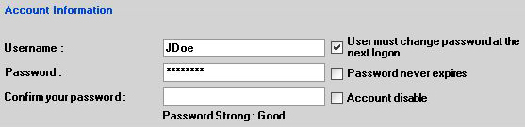
When you enter the password, a checkout is done about the toughness. If you choose that password never expires, a popup appear and says that “The user will not be required to change the password at next logon”.
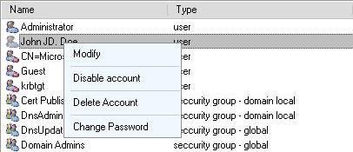
Make a right click on your User to “Enable” or “Disable” it. The icon change when a User is disabling.
You can too “Delete” this object or “Modify” it.
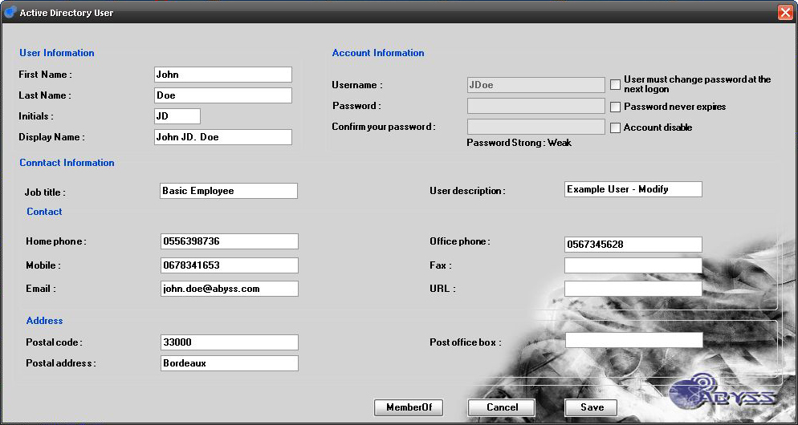
When you modify a User, the User’s window open filled. You can change the value of all properties and add the User to a Group by clicking on “MemberOf”.

In the “MemberOf” window, double click on the group desired to add it.

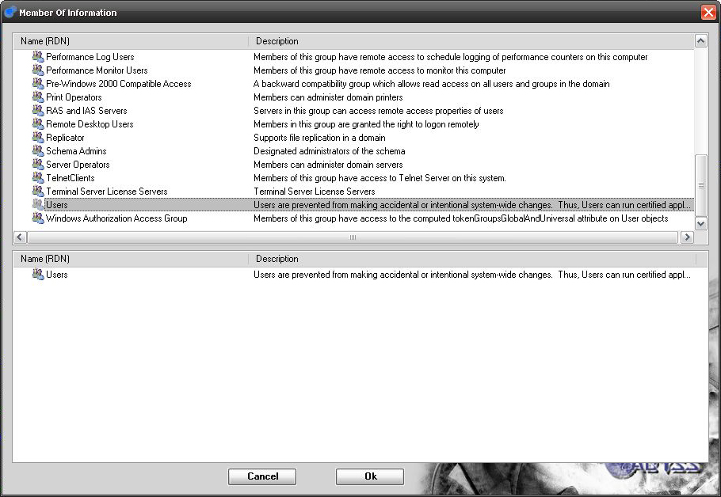

Manage Computers

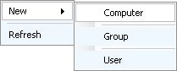
To Create a Computer, make a right click somewhere on the tree view and click on Computer.

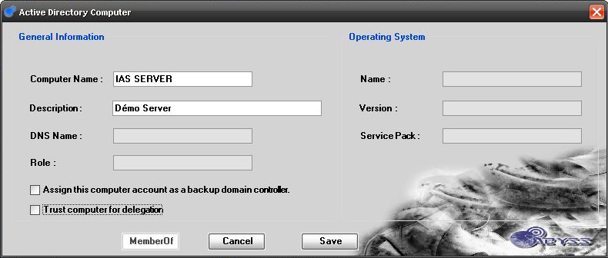
The Computer’s window open and allow you to create one. If you check “Trust computer for delegation”, a popup alarm you that this is a security-sensitive operation.

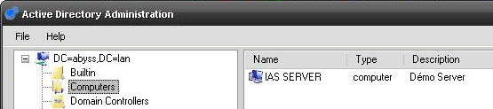
After creation, you can see your Computer in the main window.

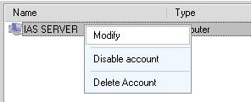
Make a right click on it to “Enable” or “Disable” your Computer.
You can too “Delete” this object or “Modify” it.
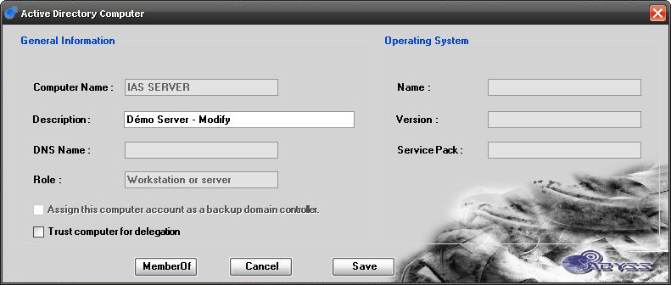
When you modify a Computer, the Computer’s window open filled. You can change the Description and some properties. You can also add the Computer to a Group by clicking on “MemberOf”.

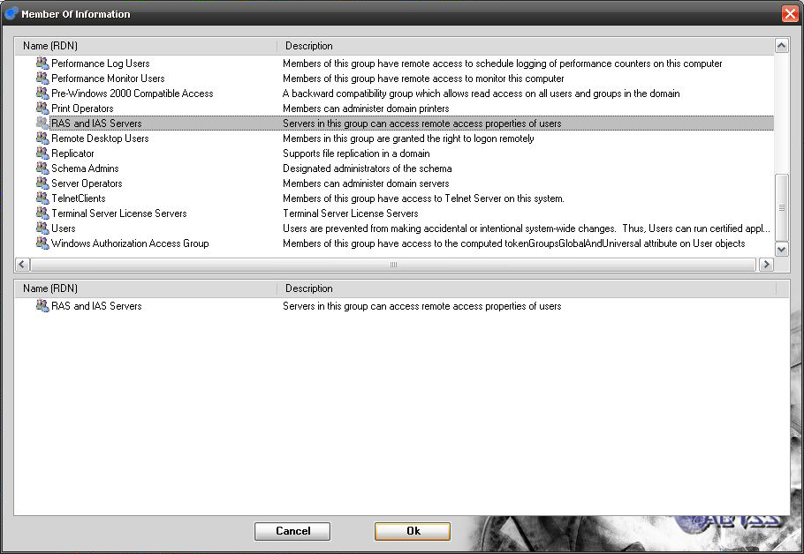
In the “MemberOf” window, double click on the group desired to add it.

Manage Groups

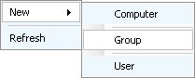
To Create a Group, make a right click somewhere on the tree view and click on Group.

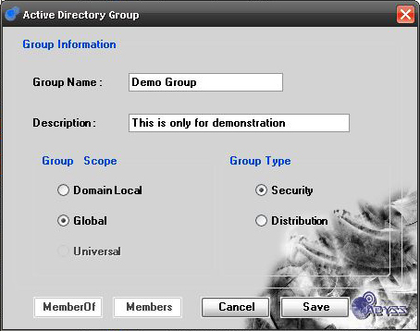
The Group’s window open and allow you to create one.

If you check “Security” in “Group Type”, you will not be allowed to check “Universal” in “Group Scope”.
A Universal Group can only be a Distribution’s Group.

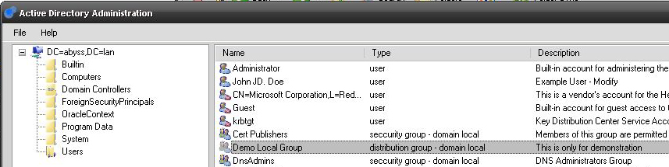
After creation, you can see your Group in the main window.

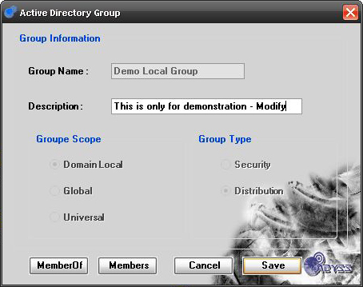
Make a right click on it to “Modify” or “Delete” your Group.
When you modify a Group, the Group’s window open filled.
You can change the Description.
You can also add the Group to another Group by clicking on “MemberOf” and assign it other members with the “Members”’s button.

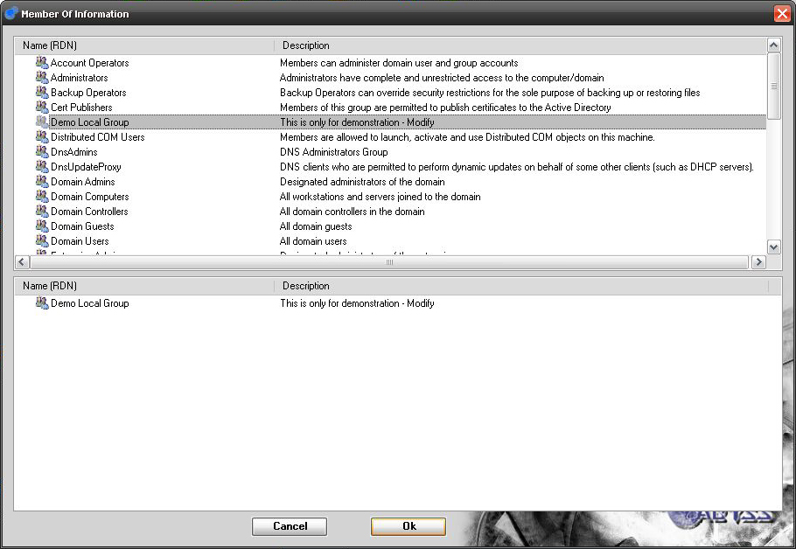
In the “MemberOf” window, double click on the group desired to add it.

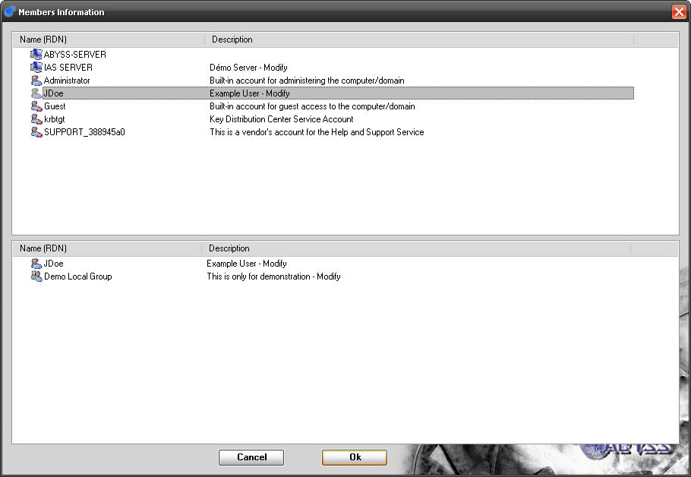
In the “Member” window, double click on objects desired (Users, Computers and Groups) to add them on your group.

You can also attribute directly a group to your objects (Users, Computers and Groups) by “Modify” them and click on “MemberOf”.

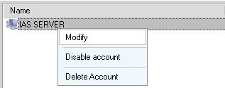

Oracle 10g

